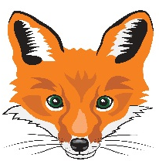
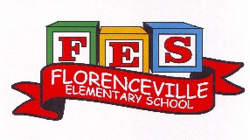
FLORENCEVILLE ELEMENTARY SCHOOL
At FES our vision is to be a community where everyone is empowered to be lifelong learners.
PRIMARY HOME LEARNING PLAN

Grade: | 1/2
TEACHER | Andree Charlebois : andree.charlebois@nbed.nb.ca
Sarah Mahar  Bridget Nugent | Principal: sarah.mahar@nbed.nb.ca; Vice-Principal: bridget.nugent@nbed.nb.ca;
Cindy Crowhurst | Resource: cynthia.crowhurst@nbed.nb.ca
Dianne Lord | Guidance: dianne.lord@nbed.nb.ca
School | florencevilleelementary@nbed.nb.ca

In accordance with the communication sent from our NB Minister of Education, Dominic Cardy, on April 2, 2020 Home learning opportunities to support literacy and numeracy outcomes will be made available online weekly by teachers.

Families are encouraged to:
-support your children to complete the options below for an average of one hour per day
-read aloud with their children daily
-consider daily physical activity and free play as an important part of their child’s mental health and skill development.

Subjects | Description of Learning Activities – Week of May 25th – 29th  **PLEASE ALSO GO BACK TO PREVIOUS PLANS TO DO YOUR FAVOURITE ACTIVITIES AGAIN**
Literacy | Activity 1: Keep doing the Literacy and Math activities from the following websites. PLEASE READ, READ, READ!! Build a fort and read inside it! An easy way to do this is to use a blanket over a table or large cardboard box.  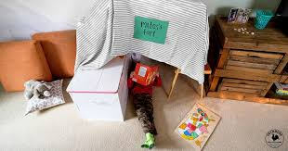  https://www.getepic.com/  https://www.abcya.com/  https://www.starfall.com/h/  www.kidsa-z.com  Activity 2: Enjoy listening to the “From 3 To 3” rhymes, riddles and oral stories!  Gr. 1 with Kristina Little: https://www.youtube.com/watch?v=ssWolijl80Y&feature=youtu.be  Gr. 2 with Karah Rhymer. : https://drive.google.com/file/d/19-zH2qbDt-TiEZ5Aw9Xk8r3tpm0z8ClM/view  Read aloud:  https://drive.google.com/file/d/1RjOD_kHm1hiS3dNYy9HkKvoBhR8eddPS/view  Activity 3: Word Work  Please see the attachments in your email for this Spring word search. A compound word is a word that is made up of two separate words (although we haven’t discussed compound words a lot with the gr. 2 students, have fun with this!) Can you think of other compound words? There is also another attachment “Spring Word Search” to work on.  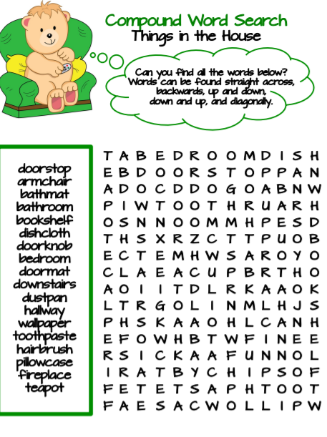  Create your own word search! Below is an example – use sight words that you need to practice spelling (look at the sight word list I sent you all). See the attachment in the email for the blank sheet (if you can’t print it, draw the lines).  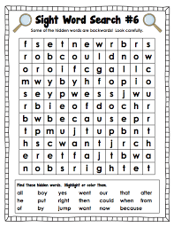  Activity 4: Word Work continued (feel free to do any activity, not just from your grade level!)  Gr.1: L-Blends  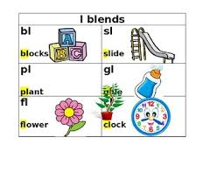  Sing along with Jack Hartmann! https://www.youtube.com/watch?v=QZ1Uu2MRXTY  Have fun with this L-blend game! Please see the attachment from the email.  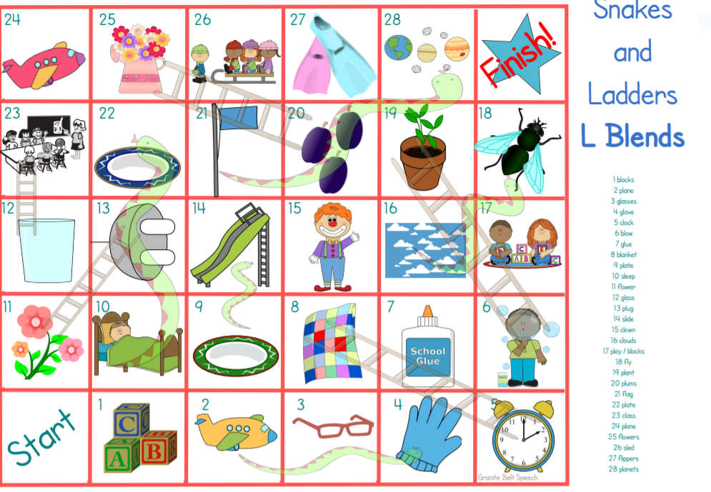  Gr. 2: Four in a Row (long i: igh, ie, i-e, y) game. Please see the attachment on this email to print (or write it out on a piece of paper). Put in a plastic pocket and use 2 different coloured erasable markers. Challenge: once you are finished the game, try spelling the words without looking!  Activity 5: Writing  Option 1: Continue working on your choice of Life cycles (insect, animal). Once you are done your picture or book, please email it to me!! I would love to see it!  Option 2: Persuasive Writing  Do you remember that we were doing this in February? Below are some topics you can write about.  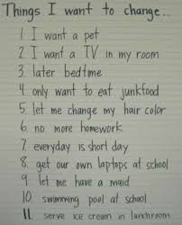  My example:  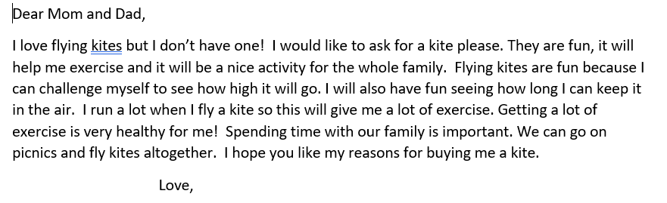  First: state what you want: I would like to ask for a kite please.  Secondly: In 1 sentence, write the 2 or 3 reasons why you want this.  Thirdly: State the reason again with details.  Lastly: End with a closing sentence “I hope you like my reasons….”
Numeracy | Activity 1: Unfortunately the IXL Math website’s month free subscription has expired but try this website for some really fun math activities!  Math Playground.com: https://www.mathplayground.com/math-games.html  Activity 2: Keep practicing your addition/subtraction math facts! See the attachment on the email for another practice sheet. If you don’t have a printer, write them out in a notebook (that was given to you). Can you beat your previous time?  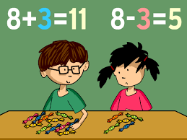  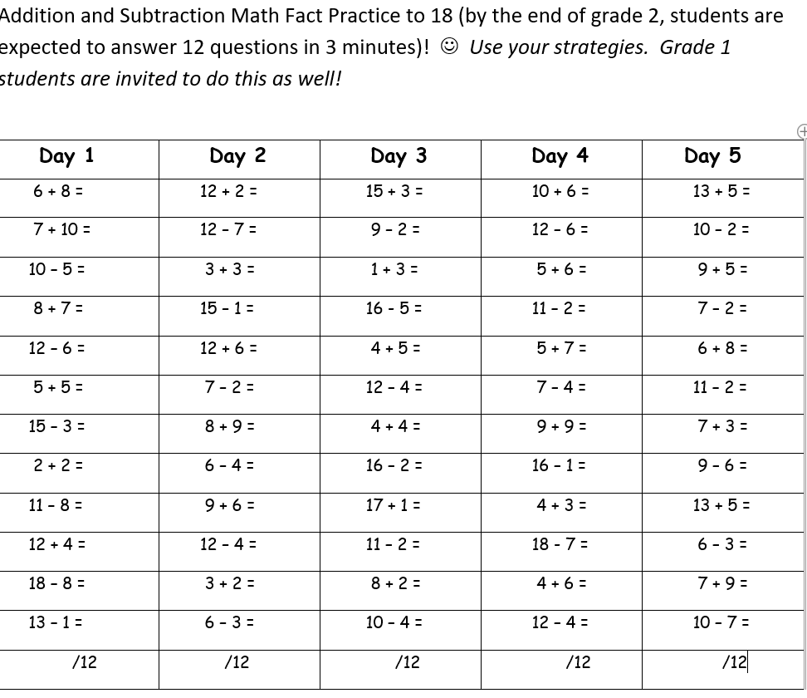  Activity 3:  Use some outside chalk and create a path (below), game or just write out some addition and subtraction facts on some pavement.  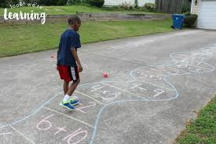  Activity 4: Outside, create addition and subtraction facts with rocks!  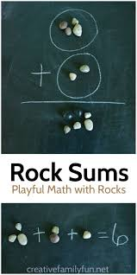  Activity 5: You can also create a game with 2D shapes! Draw a 2D shape with chalk and have someone give clues, “Step on a shape that has 3 sides”, “Step on a shape that has 4 vertices” or “Step on a shape that is curved”.  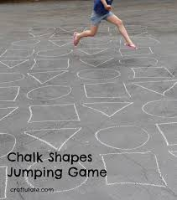  Activity 6: Jumpy Card Game  https://www.youtube.com/watch?v=51euYjNIOmk&feature=youtu.be  Watch this video on how to play “Jumpy Card Game”. Remove the face cards, choose 4 to 6 cards and add to find the total sum. Winner has the highest sum! When you are adding them together, use a 100 chart or ten frames or base ten models to help you or use your mental math strategies!  Activity 7: Mass (how heavy something is)  Videos to watch (links are noted below):  https://www.youtube.com/watch?v=QCPYaTx2v0w  https://www.youtube.com/watch?v=iiNpztrJmZQ  https://www.youtube.com/watch?v=1QUHONch0-4  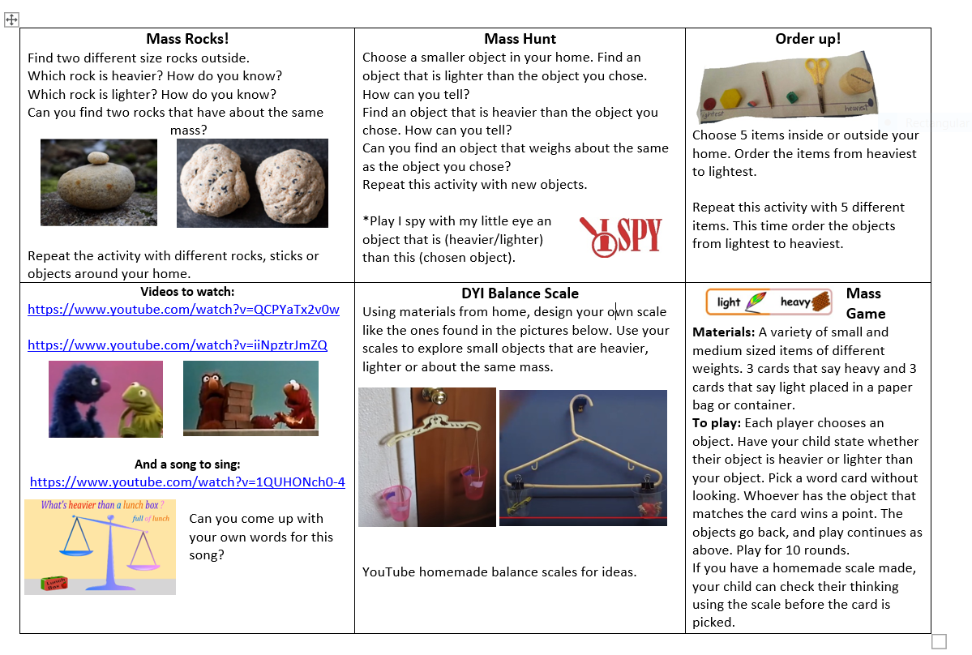
Other areas of interest/learning experiences | French: Quel temps fait il ? (What is the weather like?) by Alain du Lait  https://www.youtube.com/watch?v=eBvJVOuBPXI  Les Saisons (The Seasons):  https://www.youtube.com/watch?v=PWhLSc_FpCM  Phys Ed: Count by 5s: Exercise with Jack Hartmann  https://www.youtube.com/watch?v=amxVL9KUmq8  Count Backwards from 100 with Jack Hartmann  https://www.youtube.com/watch?v=Ss-azuApvA0  The FES Fox Makers Challenge continues! Have fun!  